Meditating on Eliot’s Four Quartets: The Fire and the Rose are One
Fr Aidan Kimel Eclectic Orthodoxy 4-30-2018
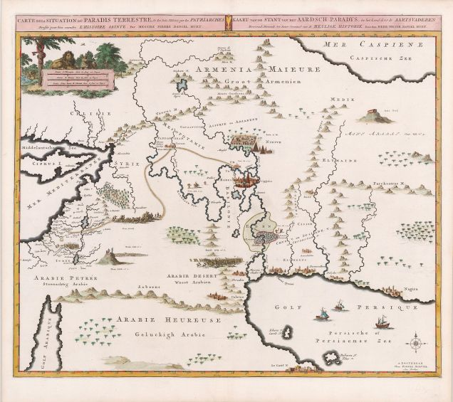
“Certainly there was an Eden on this very unhappy earth,” J. R. R. Tolkien wrote to his son Christopher in early 1945. “We all long for it, and we are constantly glimpsing it: our whole nature at its best and least corrupted, its gentlest and most humane, is still soaked with the sense of ‘exile.’ … As far as we can go back the nobler part of the human mind is filled with the thoughts of sibb, peace and good will, and with the thought of its loss. We shall never recover it, for that is not the way of repentance, which works spirally and not in a closed circle; we may recover something like it, but on a higher plane” (Letter 96).
The loss of Eden and a longing for its recovery permeates the Four Quartets of T. S. Eliot. Not a melancholic nostalgia nor an overwhelming desire overtly expressed–yet an apprehension nonetheless of a world that never was and yet is lost (Sehnsucht, perhaps, rather than saudade–or am I importing my romantic sensibility into the Quartets?). We sense it in Burnt Norton, when we walk into what was once surely a well-manicured rose garden yet now fallen into dilapidation and decay. “In the autumn heat, through the vibrant air, / And the bird called, in response to / The unheard music hidden in the shrubbery.” We sense it in East Coker, when on a midsummer night we hear “the music / of the weak pipe and the little drum” and watch the dancing around the bonfire. “Feet rising and falling. / Eating and drinking. Dung and death.” We sense it in The Dry Salvages, standing on the shore and listening to the navigational buoy: “tolling bell / Measures time not our time, rung by the unhurried / Ground swell.” We sense it in Little Gidding, as we kneel in the “world’s end,” where believers have prayed for generations. Intimations of Eden lost. Intimations of a paradise we would recover, if we only knew how. Intimations of eternity. But only intimations. Eliot’s sensibility is too chastened to permit more than a bare glimpse. “The only hope, or else despair / Lies in the choice of pyre or pyre.”
We shall not cease from exploration / And the end of all our exploring / Will be to arrive where we started / And know the place for the first time. / Through the unknown, remembered gate / When the last of earth left to discover / Is that which was the beginning; / At the source of the longest river / The voice of the hidden waterfall / And the children in the apple-tree / Not known, because not looked for / But heard, half-heard, in the stillness / Between the two waves of the sea. / Quick now, here, now, always— / A condition of complete simplicity / (Costing not less than everything)
The poems of the Quartets have been an exploration, finally brought to conclusion yet not conclusion. Temporal and finite, we cannot withdraw from the process of becoming. We started in the Garden from which we were expelled in the unremembered yet remembered past. The poet now brings us back to the Garden we cannot find. We walk through the gate, long-guarded by the angel with flaming sword. We have come to the source of the great river that flows from Eden. We hear the hidden waterfall and the sweet laughter of Adam and Eve. As St Irenaeus taught us long ago, they are but children in their innocence, “unaccustomed to and unpracticed in perfect discipline” (Against Heresies IV.38.1). They have not yet partaken of the forbidden fruit. Or perhaps what we hear is the laughter of humanity rescued from hades and restored to paradisal life. We rejoice in their play and yearn to join them in their gaiety and frolic. The original prohibition has been lifted. There is now only the freedom of a humanity transfigured in Christ. But we must be very quiet, for the sounds of the new Eden can only be heard “in the stillness / Between the two waves of the sea.”
Readers of The Lord of the Rings cannot but think of Frodo’s dream in the house of Tom Bombadil:
That night they heard no noises. But either in his dreams or out of them, he could not tell which, Frodo heard a sweet singing running in his mind: a song that seemed to come like a pale light behind a grey rain-curtain, and growing stronger to turn the veil all to glass and silver, until at last it was rolled back, and a far green country opened before him under a swift sunrise.
The dream comes to realization when Frodo sails with Gandalf across the sea to the Undying Lands:
And the ship went out into the High Sea and passed into the West, until at last on a night of rain Frodo smelled a sweet fragrance on the air and heard the sound of singing that came over the water. And then it seemed to him that as in his dream in the house of Bombadil, the grey rain-curtain turned all to silver glass and was rolled back, and he beheld white shores and beyond them a far green country under a swift sunrise.
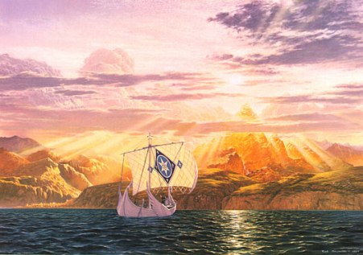
We search for the Eden we have lost—for the sonorous singing just beyond the veil of glass and silver, white shores and the far green country, the still point of the turning world. For this Eden we would surrender all; for this Eden we must surrender all.
And all shall be well and / All manner of thing shall be well / When the tongues of flame are in-folded / Into the crowned knot of fire / And the fire and the rose are one.
T. S. Eliot brings the Four Quartets to glorious consummation. Movement and stillness, sound and silence, violence and peace, death and life, time and eternity—all reconciled in the flames of the divine Love. Not a return to an Eden irretrievably lost but the transfiguration of this moment, every moment, now, here, every beginning and every ending. All shall be well. All is well. The fire and the rose are one. Amen.
“It is done! I am the Alpha and the Omega, the beginning and the end.”

