**The quest for the Holy Grail**

The quest for the Holy Grail has obsessed everyone from medieval poets and crusading knights to modern churchmen, historians, archaeologists, filmmakers, novelists and Nazi leaders – yet we don’t know what it looks like, or even whether it exists at all.

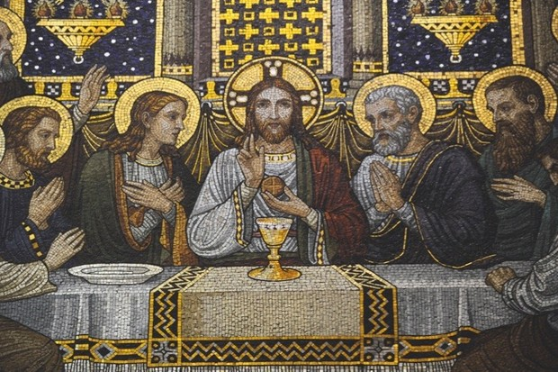

In the most popular version of the story, the Holy Grail is a chalice used by Jesus during the Last Supper, which was later employed as a vial for his blood. It was seemingly smuggled across the Holy Land and Europe to Britain. Despite a series of mysterious Grail guardians, including the Fisher King and the Knights Templar, at some point the chalice disappeared.

The sacred silverware became spliced with other legends, invested with mythical powers, and hijacked by conspiracy theorists and demagogues. Pat Kinsella separates the few facts from the profuse fictions that continue to evolve around this elusive relic…

**Birth of a legend: Where did the Holy Grail come from? And what might it be?**

Holy relics purporting to originate from the earthly life of Jesus are common currency across the Catholic world – with various churches claiming to hold everything from the Holy Prepuce (Jesus’s foreskin) through to nails used during his crucifixion. The most iconic and sought-after souvenir of all, however, is the ever-elusive Holy Grail.

The enduring obsession with the Holy Grail is fuelled by the fact that its form, location and very existence remain a complete enigma. It’s popularly believed to be a goblet used during the Last Supper and then employed by Joseph of Arimathea to catch Christ’s blood when his side was pierced with a spear during his crucifixion. However, some depictions have it as a bowl or a serving plate, or even as the womb of Mary Magdalene – in a scenario where she bears Jesus’s offspring.

The Holy Chalice from the Last Supper is referenced in the Gospels of Matthew, Mark and Luke (which historians believe were written c80-100 AD), but it was 1,000 years later that the tale of the Grail became popular, when the medieval romantics began to pen poems about it, entwining the yarn with Arthurian sagas.

The first-known reference to the Grail was made by French poet Chrétien de Troyes in Perceval, le Conte du Graal (which translates as ‘Percival, the Story of the Grail’), an unfinished poem written sometime between 1181 and 1190. Chrétien credits a source book, but the original work remains a mystery.

His fantastical yarn sees Percival – one of King Arthur’s knights  – visit the realm of the Fisher King (the last in a line of men entrusted with the keeping of the Grail). There, he beholds several revered items, including a graal (‘grail’) – an elaborate bowl from which the King eats a communion wafer. Although the Grail is more prop than main player in this poem, it inspired other writers to develop the concept.

In Joseph d’Arimathie, written between 1191 and 1202, fellow Frenchman Robert de Boron fused the Holy Chalice used at the Last Supper, and the Holy Grail, a vessel containing Jesus’s blood. Joseph of Arimathea is cast as the protector of the Grail, the first of a long line of guardians that will include Percival.

In the early 13th century, German poet Wolfram von Eschenbach developed the story in Parzival, (‘Percival’), an epic poem in which the hero embarks on a quest to recover the Grail. The Welsh romance Peredur continued the theme, but the story really took form in the Vulgate Cycle, a series of Arthurian legends written anonymously in the 13th century.

Two centuries later, Sir Thomas Malory translated these legends into English in Le Morte D’Arthur and the sagas – especially the quest for the Grail – have enjoyed waves of popularity ever since, being retold by a colourful collection of raconteurs from Wagner and Tennyson through to Monty Python, Spielberg and Dan Brown. But is there any fact amongst all the fantasy?

**The Grail trail: For centuries, explorers have chased the Grail’s shadow all over the planet**

Although most popular versions of the story ultimately point towards the chalice being transported to England, committed Grail hunters have chased the holy relic all over the world. Every perceived clue from ancient texts has been painstakingly pursued, while long-shot leads and far-fetched theories have led their followers to some fairly unlikely corners.

Over 200 churches and locations around the globe have laid claim to having current or historic possession of either or both the Holy Chalice and the Holy Grail – with some stretching the realm of credibility much further than others. Having a semi-plausible relic or a good miracle story can generate a boom in tourism for otherwise out-of-the-way destinations. As the public’s obsession with the Grail tale shows little sign of abating, it’s become big business, right around the world…

***Basilica of San Isidoro in León, Spain***

Home to the Chalice of Doña Urraca, a jewel-encrusted onyx goblet identified as the Holy Grail by author-researchers Margarita Torres and José Ortega del Rio in their 2014 book, The Kings of the Grail. The chalice has been in the Basilica since the 11th century, after apparently being transported to Cairo by Muslim travellers. It was later given to an emir on the Spanish coast who’d helped famine victims in Egypt, and passed to King Ferdinand I of Leon as a peace offering by an Andalusian ruler. Carbon dating suggests the chalice was made between 200 BC and AD 100.

***Cattedrale di San Lorenzo, Italy***

House of the Genoa Chalice, once thought to be made from pure emerald and a hot contender for the Holy Grail, until it was transported to Paris after Napoleon conquered Italy and came back broken – revealing the ‘emerald’ was, in fact, green glass. This news would have come as a disappointment to the Genoese soldiers, who named it as their chief target when they defeated the Moors and sacked Almería in a ferocious conflict in 1147.

***Metropolitan Museum of Art, New York City, US***

Current home of the Antioch Chalice, a silver-and-gold double-cup design ornament, touted as the Holy Chalice when it was recovered in Antioch, Turkey, just before World War I. The museum has always described this claim as ‘ambitious’ and the relic was recently outed as a standing lamp, not a chalice, believed to have been made in the sixth century AD.

***Catedrale de Valencia, Spain***

The Valencia Chalice is housed in its very own consecrated chapel. The agate cup was reportedly taken by Saint Peter to Rome in the first century AD, and then to Huesca in Spain by Saint Lawrence in the third century. Some Spanish archaeologists say the cup was produced in a Palestinian or Egyptian workshop between the fourth century BC and the first century AD.

***The Jerusalem Chalice, Israel***

In the seventh century AD, a Gaulish monk named Arculf recorded seeing a vessel he believed to be the Holy Chalice contained within a reliquary in a chapel near Jerusalem, between the basilica of Golgotha and the Martyrium. This is the earliest known first-hand report of the Grail after the crucifixion, and the only known mention of the Grail being seen in the Holy Land. The fate of the chalice he described is unknown. It has also been claimed that the Grail is hidden with other holy relics in the vast underground sewer complex of Jerusalem, beneath the legendary Solomon’s Temple.

**Over to Albion: The Grail myths are as much entwined with British folklore as international history…**

After the crucifixion of Jesus, for reasons that remain unclear (and which may well owe more to poetic license and political and economic expediency than historical fact), the story of the Holy Grail is quickly transplanted from the Holy Land to the green and pleasant land of England.

According to legends that have been doing the rounds for at least the last 800 years, the keeper of the Grail, Joseph of Arimathea, arrived in England in the first century AD. He crossed the Somerset Levels (then flooded) by boat to arrive at the foot of Glastonbury Tor on an island known in Arthurian mythology as Avalon.

At the foot of Wearyall Hill, just beneath the Tor, the tired missionary thrust his staff into the ground, and rested. In the morning, so the story goes, his staff had taken root and grown into an oriental thorn bush now known as the Glastonbury Thorn.

Joseph then went on to found Glastonbury Abbey, and set about converting the locals to Christianity – with a staggering success rate. By 600 AD, England had a Christian king: Ethelbert. Meanwhile the Grail – which, according to some stories, was buried at the entrance to the underworld in Glastonbury – became firmly interwoven into myths about King Arthur and the knights of the Round Table.

Contemporary records mention none of this, though, and the story only became popular after the publication of Robert de Boron’s fanciful poem Joseph d’Arimathie at the end of the 12th century. The area may have been a significant site for pre-Christian communities, but Glastonbury Abbey was almost certainly established by Britons in the early seventh century.However, stories connecting the dots between the site, Arthurian legend, the presence of the Holy Grail and miracles performed by ‘blood relatives’ of Jesus were all excellent marketing for the pilgrimage trade at Glastonbury. The local monks wholeheartedly endorsed the fables, right up until the Abbey was dissolved in 1539, during the English Reformation.

An early example of this can be seen when, in 1184, a fire destroyed most of the monastic buildings at Glastonbury. A few years later, around the time Joseph d’Arimathie was published, King Arthur and Queen Guinevere’s tomb was miraculously discovered in the cemetery. There was a spike in pilgrimage traffic and the funds needed to rebuild the Abbey.

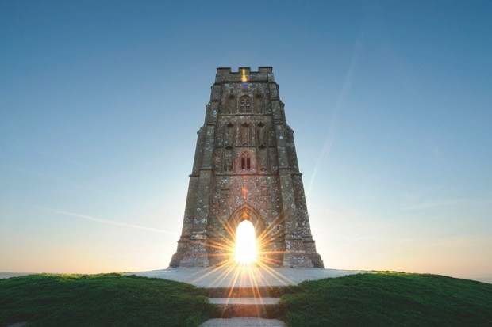

According to myth, King Arthur’s wizard Merlin still roams Glastonbury Tor.

**A good story: From medieval poems to modern action movies, the Grail has provided centuries of entertainment**

For two millennia, the legend of the Holy Grail has been reported and contorted by imaginative poets, painters, writers, comedians and filmmakers – to such an extent that the small number of known facts have become increasingly hard to sift from an overwhelming mountain of speculative or purely artistic ideas.

Amateur historians and professional authors have gone off on wild tangents, generating countless pseudo-historical books masquerading as seriously researched non-fiction. Indeed, a vast amount of flimsy and fantastical evidence has been reported as fact to support questionable theories. As a result, the Grail story has assumed a life of its own – one that constantly plays out on the pages of books and websites, and on TV and cinema screens – and each generation consumes a new version of it.

**Back in the limelight: Victorian revivalism**

During the deeply religious fervour of the Victorian era, medievalism was the all the rage and yarns from the Middle Ages, such as Malory’s Le Morte D’Arthur, were constantly being reprinted and consumed by a public hungry for tales of chivalry and salvation.

The quest for the Holy Grail was a recurring theme across the arts throughout the age, but everything was based on the medieval myth, rather than known facts and historical events.

Painters began to depict scenes from Arthurian legends, especially members of the ever-earnest Pre-Raphaelite Brotherhood. When commissioned to decorate Oxford University’s new union building, founder of the Brotherhood Dante Gabriel Rossetti used the Holy Grail as his central theme – thus seeding an awareness and interest in the subject in the fertile minds of future generations of scholars. It was a theme that Rossetti would return to numerous times in his watercolour paintings.

Over several decades, the pre-eminent poet of the era, Alfred Lord Tennyson (Poet Laureate for 40 years during Victoria’s reign), published the epic Idylls of the King, a cycle of twelve narrative poems that retell the legend of King Arthur and his knights – including, of course, the quest for the Grail. These immensely popular poems were dedicated to the late Prince Albert.

William Morris, one of the most significant cultural figures of the era whose talents spanned everything from poetry to interior design, was also acutely interested in the sagas. He wrote verses about the Holy Chalice, and collaborated with Pre-Raphaelite artist Edward Burne-Jones to produce vast tapestries depicting the quest for the Grail, which were hung on the walls of the wealthiest businessmen of the industrial age.

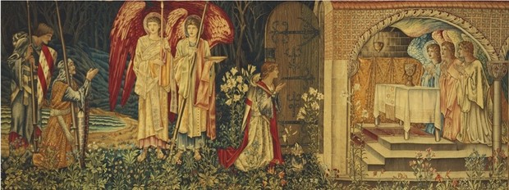

This vast Victorian tapestry, named ‘The Achievement of the Grail’ measures 2.4 metres high by nearly 7 metres long. It is currently on display in the Birmingham Museum and Art Gallery.

**20th-century style: The quest on screen**

The Grail has been quested after on big and little screens since technology made it possible, but most people will recall the story from at least one of three successful cinematic renditions…

***Excalibur***(1981), was directed by John Boorman and starred Nigel Terry, Helen Mirren, Patrick Stewart and Liam Neeson, among many others. An action-packed adventure fantasy, it follows the story of King Arthur, from the moment he pulls the sword from the stone, to the quest for the Grail (via Guinevere and Lancelot’s affair). The film, in contrast to most of the medieval literature, has Percival retrieve the Grail for an ailing Arthur, who sips from it and is restored to health.

***Monty Python and the Holy Grail*** (1975), was the Python posse’s first foray into full-length feature films and it is a gloriously ridiculous romp through the Arthurian sagas, with Graham Chapman in the lead role. As the hapless knights search for the Holy Grail they face various challenges and dangers, not least a killer rabbit.

***Indiana Jones and the Last Crusade***(1989), the third of Steven Spielberg’s successful series of movies starring Harrison Ford as a swashbuckling archaeologist, sees Indy in action trying to rescue his father (Sean Connery). He then needs to find the Holy Grail before the Nazis get hold of it and use it to achieve world domination. Sound stupid? You might be surprised how close some of the plot elements are to the truth…

*This article was first published in the October 2015 issue of****History Revealed****.*