Christ at the Center: Gerard Manley Hopkins’

“As kingfishers catch fire”

Dr. Holly Ordway, 2021

“Taste and see that the Lord is good,” the Psalmist tells us (Ps. 38:4). It’s a good way to sum up ‘leading with beauty’ as an approach to evangelization. We are inviting others to the great wedding feast, the banquet of the Lord. To be sure, it’s vitally important to share with them the fact that this banquet is real, not imaginary (truth), and that it’s perfectly nourishing above all other foods (goodness). But before people will care about that side of things, they need to be interested in the meal itself—and a whiff of what’s cooking in the kitchen is far more effective than a nutritional chart when it comes to convincing a busy and distracted person to sit down for a meal.
How can we do that? One way is through literature that gives a taste of the banquet, a glimpse of what it means to be a Christian, to live and move and have our being in a world that is so much richer, deeper, more meaningful than the flat, textureless world of secular materialism. Poetry has particular value in this regard, because a single poem can be offered as a small taste—an hors d’oeuvre, as it were: non-threatening, inviting, intriguing, suggestive of a greater feast.
The poetry of Gerard Manley Hopkins stands out in this regard. A Catholic priest with a keen awareness of beauty, especially in the natural world, and an astonishing ability to pack his poems full of meaning, Hopkins offers many glimpses of what it means to love Christ and follow him. Some of his poems are wrenching in the way they face up to suffering and depression; others are paeans of praise and joy.
“As kingfishers catch fire” is particularly notable, as it gives a vivid picture of what it means to have one’s identity in Christ. It’s not an easy poem—none of Hopkins’ poems could be described as easy—but it’s well worth slowing down for a careful, attentive, savoring read. Because his poetry is challenging yet rewarding, I’ve extensively annotated all of his poems included in the new Word on Fire Classics’ Ignatian Collection. Let’s consider this poem. First, here’s the poem itself and my annotations from that volume:
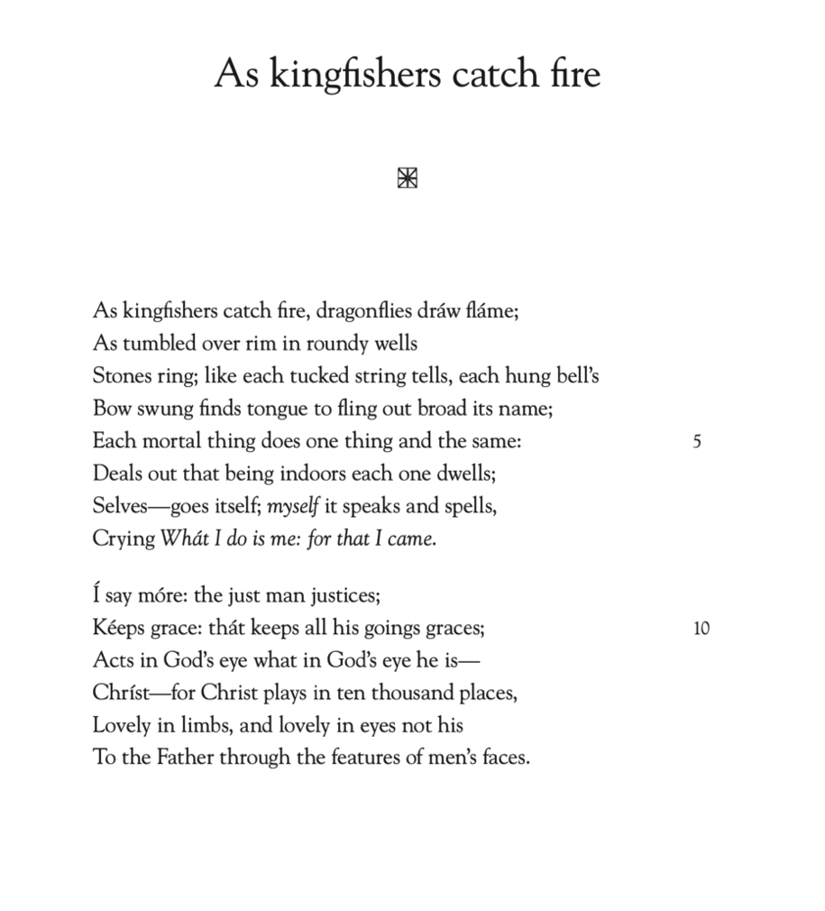
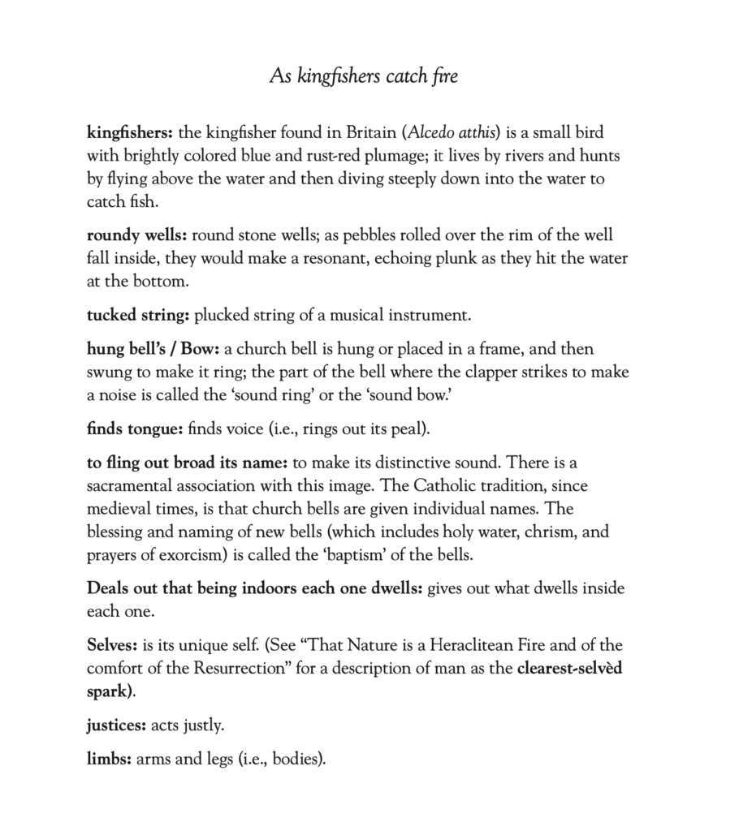
Let’s have a closer look at what Hopkins is doing here.
“Kingfishers” is a deeply experiential poem. The octet (the first eight lines) and the sestet (the next six lines) flow from beginning to end with pauses but no full stops; like water flowing downhill, we fall from one image to the next in sequence, ending up pausing at the opening phrase of the sestet: “I say more.” Reading the poem aloud (go ahead, do it!) brings out its music. Hopkins uses alliteration extensively, so that it carries us onward from one phrase to the next, and emphasizes certain words to bring the images into sharper focus. Look at even just the first three lines:
As kingfishers catch fire, dragonflies draw flame;
As tumbled over rim in roundy wells
Stones ring; like each tucked string tells…

He also uses end rhyme, a fascinating drawing-together of two strands of English poetry, for unrhymed alliterative verse is the Old English tradition, and end-rhyme is a French-influenced Middle English innovation. Hopkins has crafted what is in effect a musical composition in English words. Not only does the poem sound beautiful but this music is paired with images of beauty. Kingfishers: brightly colored, fast-moving birds; dragonflies: elegant, jewel-toned insects whose name itself echoes fantastic creatures of medieval myth. The created world, made by God through Christ, is faithful in being what it was made to be.

Then the poem moves on to the human interaction with God’s creation: wells, evoking fresh water, but also mystery and magic (think of tossing coins down a wishing well), and a child’s playfulness in tossing a stone into a well just for the pleasure of hearing the ring of the falling stone. The swinging bell flings out the note in joyful exuberance, and here, with the image of the bell calling out its name, Hopkins subtly evokes the sacrament of Baptism.

These lines draw us into an experience of pure, unmediated joy—and then Hopkins tells us what that joy is, starting with the hint given by the bell calling out its name. “Each mortal thing does one thing and the same . . . myself it speaks and spells; / Crying What I do is me.” All things naturally express their own identity—and the poem’s first lines have helped us feel, deep in our bones, that this identity is a joyous one. Hopkins goes a step further: following “what I do is me” we have “for that I came”: he takes us in one beat from identity to purpose.
Having introduced the idea of purpose at the pivot-point of the poem, Hopkins says, “I say more,” declaring that he will unfold the meaning behind all of this.

However, he does not immediately name Christ; rather, he turns first to the human experience, “the just man justices”; by making a verb out of the noun justice, Hopkins makes the connection of identity and action concrete. This just man “Keeps grace: that keeps all his goings graces”—a play on words that emphasizes that God’s gift of grace is what allows the man to have all that he does unfold in grace. The word “grace” helps the reader make the connection between joyful identity and Christ before Christ is named, so that the evocation of our Lord will be heard not as an evangelizing add-on, but as the piece that makes all the rest fit together perfectly.

For Hopkins points to Christ at the heart of everything. The just man “Acts in God’s eye what in God’s eye he is— / Christ.” Here we have a poetic restatement of St. Paul’s words: “It is no longer I who live, but it is Christ who lives in me” (Gal. 2:20). Hopkins closes the poem with words that express the joy of living out that identity: “for Christ plays in ten thousand places, / Lovely in limbs, and lovely in eyes not his / To the father through the features of men’s faces.”

The fact that “Kingfishers” is beautiful purely as a poem draws us deeply into the heart of this experience: as poet, Hopkins takes us through a lived moment of pure, joyful Christian identity. We feel the joy of the kingfisher, dragonfly, stone, bell, and man each being exactly what they are meant to be: rooted, grounded, graced in Christ. And we are invited to taste further—invited to the banquet.

